Church of Fracis De Sales
Parish Council
Meeting Minutes
November 8, 2023

In attendance: Eric Chadwell, Cheryl Henig, Mary Flaherty, Ed McNamee, Norah Iveson
Father Koo, Paul Flaherty, Leon Iveson
Mike Henig, Helen Yacobucci,
Next Meeting: January 10, 2024 at 5:30 p.m.
Item
No.
I.  II. | Please see Appendix A for the Agenda.  Parish Council Meeting was opened at 05:32 pm by Eric Chadwell.  A quorum was reached.  Eric Chadwell led the opening prayer.  The previous meeting minutes were approved as posted.
IV. | Reports
A. | Admin Report: Paul Flaherty  Please see Appendix B  In summary, the lights have been installed in the columbarium; the sprinkler system has been turned off to repair a small leak; and we need help directing people for the funeral to be held on Saturday, November 11, 2023. Members of the Parish Council will do this.
E | Financial Report: Leon Iveson  Please see Appendix C for the entire report.  The Offertory has been very beneficial; we are $15K above the projected amount and income exceeded expenses by $8K. However, we need to encourage fund raising to grow the building fund.
C. | Liturgy: Father Koo  - We need a schedule of events/activities from each ministry for the year. These activities will be combined into a single calendar to ensure improved planning and coordination.  - Although improved, our bulletin is in need of further change. It was suggested that we go to a bi-fold document as we had prior to Covid. We need someone to lead this task.  - A potential parishioner has contacted Father. He refurbishes tabernacles and has offered to inspect ours to see if it is salvageable. We need two tabernacles, one in the chapel and one on the altar.  - There is a need to engage more parishioners in the ministries. The ministries need strengthening and some ministry leads are no longer active in the church.
V.  a. | COMMITTEE REPORTS  Parish Outreach – Helen Yacobucci  Please see Appendix D.  In summary:  - On 11/15, we will pack 600 snack packs. Picking supplies up is becoming an issue. Helen needs additional help in this regard. Mike and Sherry Henig and Norah and Leon Iveson will help to pick up supplies on the 13th.  - We have received funding from the Owens Foundation for the Snack Pack program. An announcement will be made Sunday to solicit additional help. Father will help in the future to recruit helpers.  - Parish Outreach has paid electric bills this month and has helped one family with their mortgage payment. It is expected that needs in the community will increase in the future.  - $500.00 has been donated to the Christmas Shop for underprivileged children.  - We will again have the Giving Tree for the elderly during Advent.  - A question was raised about the process of selecting clients for assistance. Clients must first file paperwork with Social Services and subsequently, Hands Across Mathews is notified. If there is still a need after these interventions, the clients seek assistance from churches. A determination is then made by Parish Outreach, and assistance (up to $300.00) is given. Clients must then wait 6 months before Parish Outreach can provide any additional funding.  - The funding for Parish Outreach was explained. Parish Outreach is a dedicated account which is funded by grants, social services, individual contributions, other church communities, as well as special offertory collections. This is done outside of the FdS operating budget. FdS does track the account but it is independently managed.
b. | Hospitality – Mary Flaherty  - Hospitality on third Sundays will include “light” refreshments such as cookies and cake and beverages. A meal will be planned on special occasions.  - There will be no hospitality on 11/19/23 due to the Yard Sale.
c. | Funeral Receptions – Mary Flaherty  - Preparations are being made for the funeral for Bill Simmons on Saturday, November 11. Since many people are expected at the funeral, the Parish Council will greet and seat attendees.
d. | Greeters/Sunday Bulletin/Ads/Ushers – Mike Henig for Paul Reardon  No report was submitted since Paul is currently in rehab. Mike Henig will call a meeting to identify a new leader for these ministries and will provide the names of potential leaders to Father Koo. Helen Keitz has solicited ads in the past and may be a good candidate for that activity.
e. | RCIA - Cheryl Henig  Mark Nichols is on track. He will receive the Rite of Sending at Francis de Sales on February 18, 2024. He will then travel to St. Pius X in Norfolk with the RCIA Team and his sponsor for the Rite of Election by the Bishop.
f. | Virtus – Cheryl and Mike Henig  - Mike and Cheryl Henig are regional trainers and have been asked by the Diocese to conduct two sessions. One will be on November 11 and the other on December 9. One person has signed up for the November session. The training will take place at FdS.  - Marie Walls has been Virtus trained.
g. | Parish Life - Cheryl Henig for Rita Engle  - Rita is in the hospital and will have heart surgery in the near future.  - The Parish picnic was a success and the weather cooperated.  - The Parish Directory is being prepared but is “on hold” for the time being. Cheryl Henig will call a meeting to determine who will complete the tasks for this endeavor if Rita Engle is unable to continue.
h. | Eucharistic Ministers – Mike Henig for Paul Reardon  The schedule has been completed through December, 2023. Mike Henig will identify potential candidates to lead this ministry if Paul is still in rehab at that time. Tina Darby is a potential candidate to lead this ministry. Mike Henig will contact her to see if she will assume this position.
i. | Ushers – No ministry leader at this time
j. | Religious Education – Ed McNamee  Please see Appendix E for the complete report.
k. | Lectors – Ed McNamee  Please see Appendix E for the complete report.
l. | Fundraising – Eric Chadwell  Oktoberfest was a great success, raising over $7,000, The next fund raiser will be the Yard Sale on November 18th.
m. | Web Master – Ed McNamee  Please see appendix E.
n. | Lectors – Ed McNamee  Please see Appendix E.  Two new lectors have stepped forward.
o. | Pastoral Care – Mary Flaherty  Mary visits 4 residents in the nursing home every Sunday and takes them Eucharist.  Paul Reardon is at Walter Reed Rehab Center with an unknown return.
p. | Music  No report submitted. Sueann Dittmeier is the lead for the folk group. Since we have additional liturgical music, a new director of music may need to be identified. Laura Emerson and Cathy Schirmer lead the choir.
VI. | Faith Formation
A. | 1. Feedback on previous sessions has been positive.  2. The next session is 12/03/23 after Sunday Mass. The topic is “who is qualified to receive Communion?”
VII. | Old Business
A. | Plan of Improvement – Ed McNamee  Work is proceeding on the Sanctuary improvements. The cost of the design work has been taken care of.
VIII. | New Business
A. | Commons Area  A suggestion was made to rename the commons area, perhaps with the name of a founding parishioner. In order to do this, we must have a rationale for the change with documentation. This discussion was tabled until some additional research is done. Ed McNamee will establish a group to complete this.
B | Liturgical Music  There was a discussion about music at Sunday liturgies. It was mentioned that the tuning of instruments and practicing scales during the readings was very distracting. The purpose of liturgical music is to enhance liturgy and lift parishioners into a prayer-filled state rather than be a distraction or the primary focus of liturgy. Father agreed to address this in the short term.
C. | Integrated Liturgy  As closure to the previous discussion, and in order to integrate the many elements of liturgy, a group will be formed to establish norms of practice. Ed Macnamee will form the committee.
IX. | Closing Prayer  Mary Flaherty led the closing prayer.

The next meeting is January 10, 2024 at 5:30 p.m.
Opening prayer – Norah Iveson
Closing Prayer – Ed McNamee

SUMMARY OF ACTION ITEMS:
- The Parish Council will greet and seat folks at the funeral on Saturday, November 11.
- Ministry leads will generate a yearly schedule of events/activities to be included in a parish-wide calendar. This will be done by January 1, 2024.
- The bulletin is in need of further improvement. No one volunteered to lead this effort.
- The tabernacle in the chapel will be evaluated for refurbishment.
- The ministries are in need of strengthening and more parishioners should be involved.
- Mike Henig will identify 3 people to take over ministry leads in Paul Readon’s absence and give the names to Father Koo.
- The Henigs and Ivesons will help pick up Snack Pack supplies on the 13th.
- An announcement will be made on Sunday to solicit more Snack Packers.
- The Parish Council will greet and seat attendees at Saturday’s funeral.
- Mike Henig was asked to contact the Diocesan Office to determine if all employees (even the cleaning staff) need Virtus training. Paul Flaherty assumed this responsibility after a discussion with Mike.
- Ed McNamee will identify a group to research renaming the Commons.
- Father Koo will address music issues.

Appendix A
Agenda Parish Council Meeting
November 8, 2023

- Call to Order – Eric Chadwell
- Opening Prayer – Cheryl Henig
- Approval of Previous Minutes

- Reports
- Administrative Report – Paul Flaherty
- Financial Report – Leon Iveson
- Liturgy – Michelle Oliver (Father Koo)
- Committee Reports - Chair
- Social Outreach – Helen Yacobucci
- Hospitality/Funeral Receptions – Mary Flaherty
- Greeters – Paul Reardon
- RCIA and Teen Sacramental – Cheryl Henig
- Parish Life – Rita Engle
- Eucharistic Ministers – Paul Reardon
- K-8 Religious Education – Ed McNamee
- Lectors – Ed McNamee
- Fund Raising Committee – Eric Chadwell
- Parish Visibility Committee – Mary Flaherty
- Webmaster – Ed McNamee
- Pastoral Care – Mary Flaherty

- Old Business
A. Plan of Improvement

- New Business

- The next meeting is scheduled for January 10, 2024.
- Opening prayer -
- Closing prayer -

- Closing Prayer – Mary Flaherty

End.

Appendix B
Administrative Report
Parish Council Meeting
November 11, 2023
CHURCH OF FRANCIS De SALES
ADMINISTRATION REPORT
PARISH COUNCIL

November 7 ,2023

- WJ Whitley Electric has installed the lights in the ceiling of the Columbarium. This came in very handy during the Memorial Service held on the evening of All Saints Day.

- On Saturday November 11th at 10:00 AM the Funeral for Bill Simmons will be held at Church of Francis de Sales. In speaking with the funeral home, they will take responsibility for parking the cars. They did ask that the parish does make people available to serve as ushers and guides inside the building.

- I have been in touch with the irrigation company regarding a repair of a small
leak that arose toward the end of the season. They will be coming out to
perform the repair and winterize the system.

Appendix C
Finance Council Report
Parish Council Meeting
November 11, 2023
Finance Report to Parish Council
November 8, 2023
Funding Snapshot as of the end of October 2023:

Total Offertory Budget: $52,333
Total Offertory Income: $67,885
Difference: $15,552

Total Income: $77,946
Total Expenses: $69,635
Income - Expenses: $8,311

We are off to a strong start for the new fiscal year…as we reached the end of October, our Total Offertory Income was $15,552 More Than our planned budget. When you look at total income versus total expenses, we are in the Positive by $8,311. We are counting on continued Parishioner offertory support and generosity as we continue through the year.

Funding Related Issues:
- Income: As we move forward, we are counting on continued Parishioner support and generosity. The bulletin includes a note to show everyone the many ways to support our Parish.

- There are lots of worthwhile opportunities for parishioners to make a difference with their money, but we need to continue to encourage everyone to fund our Parish first so we can meet our budget and remain viable.

- Fundraising: Cathy Schirmer is the Finance Council rep to the Parish Fund Raising Committee. We are hoping for more fundraising opportunities throughout the rest of the fiscal year.

Leon Iveson
FdS Finance Chair
Email: AIRLFTR@gmail.com
Cell: (501) 749-2276

Appendix D
Parish Outreach Report
Parish Council Meeting
November 11, 2023

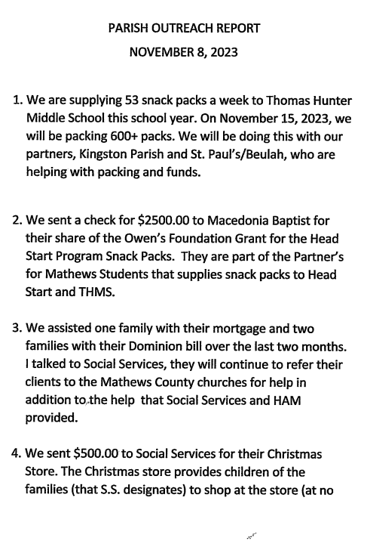

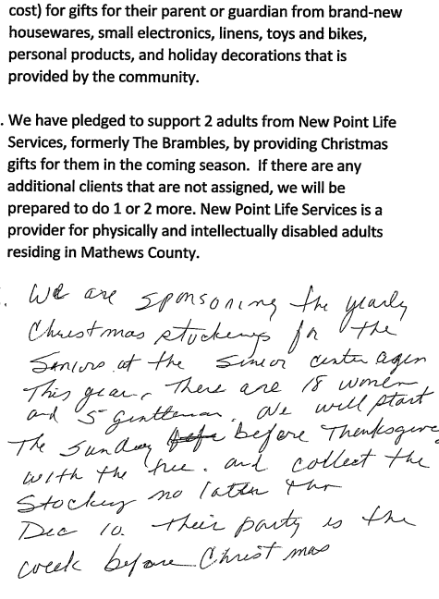

Appendix E
Religious Education Report
Web Master Report
Lector Report
Parish Council Meeting
November 11, 2023
Faith Formation — Ed McNamee

Parish Catechetical Plan
- Following our first Adult Faith Formation Night, Fr. Koo asked if we had a comprehensive
plan for adult catechesis. It is in work and will include parish-wide catechesis, small-
group studies, Parental Catechesis in conjunction with Religious Education, and
Catechesis Formation.
Since the plan will require assistance and coordination with other ministries, will share
it with them before forwarding itto the council for their review and approval by Fr. Koo.
Adult Faith Formation:
- Our first faith formation night since before COVID appears to have been a success.
Approximately 37 were in attendance; all reviews were positive and parishioners seem to
be interested in more faith formation. This success was the result of the work of the Holy
Spirit upon our parish to come together as one to provide and participate in a parish-wide event that grows our community of faith.
- Our next Adult Faith Formation is scheduled for Sunday, December 3rd after Mass. The
topic of this program is "The Real Presence in the Eucharist." It is requested that to
maximize participation, this event be accompanied by light refreshments only _(such as coffee, juices, donuts) so we can get paricipants seated and begin the program which
should run for approximately one hour.

Religious Education
RelEd—Middle School (Michelle Haas)
We have been asked to identify a digital Bible for one child who is sight-impaired. We
have found a Catholic children's Bible, published in a digital format, by St. Mary's Press.
They have a program that under certain circumstances provides this resource free to
qualifying children. I have asked the parent to evaluate the sample from St. Mary's Press
and to let me know if it is appropriate for her child. We may be able to get this bible
free; if we cannot get it free, we will look for other ways to buy it.
RelEd—High School (Courtney Hudson)—NTR
RelEd—All grades:
Our focus for Advent will be how we can bring more catechesis home to parents.
Parents have the primary responsibility for the catechesis of their children but they are
uncomfortable with that role because they generally believe they do not know what it is
they should be discussing.
RdEd—Hispanic Speaking Students
- We have two RelEd students whose primary language is Spanish. One student is 11
years old (5th grade) and his mother speaks no English. Our first step with this student
is to determine if he has had his first sacraments. Pat Noonan is assisting with
translation. The other student is in middle-school but his mother speaks English but
does not read it. This student does not participate in class as regularly as we like.
- Both mothers have indicated they would be open to at-home catechesis in their native
language. We are investigating, with the help of the diocese, at-home programs where
the parents can catechize their children and come in once a month to review what they
have learned and preview what is next. This is a bit of a hurdle for our faith formation
program to climb, but we are beginning to see things come together that may allow it to
take hold. We should know by the beginning of Advent if we will be able to execute this
ambitious plan.
- There are other Hispanic families that live in Mathews County. Our response to the first
family could possibly determine if other families get the word that we are a welcoming
parish.

Sacramental Preparation
Baptism (Ed McNamee)—NTR
First Holy Communion (Michelle Haas— NTR
Confirmation (Jessie Miller):
- We will be able to report the number of Confirmands who will be prepared for Spring
Confirmation at the next Parish Council Meeting. We believe that two of our children
will be Confirmands next year.
Lectors — Ed McNamee
- We have two parishioners who have accepted the call to become lectors. As soon as
time permits we will provide an update for all lectors and introduce our new lectors to
their ministry.
Web Master — Ed McNamee
- The Sunday Mass times were incorrectly reporting our Masses staring at 10:00 AM.
This has been corrected.
- I am no longer able to retrieve Google Analytics which report website usage. I may be
able to resume these analytics, but the diocese does not support this function.
- I would like to get a better idea of who uses the website, especially the calendar. While
it can be extremely useful to the parish and especially ministries and committees, it
takes time to post it. Please let me know what you think works and does not work.
New Business
- Naming the Commons Area: Proposal to commemorate the contributions of Bill and
Georgiana Simmons to our parish and greater Mathews community by naming the
commons area "The Bill and GeorgiarflSimmons Parish Hall," or "Simmons Hall" for
short.
- Disruptions during our Liturgy: Proposal to discuss noise during our liturgy and options
to minimize or mitigate it when necessary, specifically tuning of instruments and
conversations during the Liturgy of the Word. Rationale: It has become clear that it is a distraction to parishioners and detracts from the intent of the liturgy for parishioners to
be active and full paricipants in the Mass.
- Tabella: We plan to trial Tabella, a free Catholic app, which allows messaging solely
within the parish.
- Phase 1: Pastoral Council members will accept the invitation download the app
and use it to communicate within the council. I encourage you to send files,
pictures, or anything you would normally send to help us understand how this
works best for us. o Phase Il: Parish kick-off on Nov 26-Christ the King, with a second kick-off the following Sunday.
Old Business:
- Plan of Improvement: Annie Dixon, the lead designer for our project at Dixon Studio,
asked if we could continue to move our project along. She was provided with a photo of
the tabernacle we expect to be able to use along with dimensions of the tabernacle and
was asked to prepare a design of our sanctuary based on that information.

